**Analysis of H1B Cases for Strategic Employer Targeting: F-1 Student under OPT**

**Delivery:** International Student on F-1 OPT, Job Seekers in the United States   
 **Purpose:** Data-Driven Recommendations for Securing Long-Term Sponsorship

### **Brief Overview**

With the current president, President Trump, stepping back to office in November 2024, the current reforms to the H-1B program have included the proposed $100,000 petition fees for new and recurring applicants for the H-1B visa. This has left numerous applicants discouraged as it has reshaped the whole mindsets of employment behavior across various industries. The following act has been imposed to promote U.S. job seekers and talent to be employed in the current market. However, as new pathways align in favor for international graduates who held F-1 visas on OPT, graduates start seeking ways to best succeed in the ever-changing market of H-1B visas. According to the USCIS in 2024, between 2020 and 2023, 54.8% of H-1B visa recipients previously held F-1 visas, underscoring the growing advantage of transitioning from OPT to H-1B (U.S. Citizenship and Immigration Services [USCIS], 2024). The following case study focuses on finding best data-driven recommendations for students under F-1 OPT, securing long-term sponsorship in the United States of America.

### **Key Research & Data Driven Findings**

**[1] Top Sponsoring Employers:**According to the analysis of the U.S. Department of Labor’s Labor Condition Application (LCA) database for the years 2020 through 2024, it was found that **Amazon, Google, Microsoft, Deloitte, Cognizant**, and **Accenture** consistently lead in H-1B sponsorship. In other sectors like manufacturing and energy, **Tesla, Intel, and Siemens** remain active sponsors. Some of the industrial and geographic trends identified are as follows:

* Technology and Consulting dominate sponsorship in California, Texas, and New York.
* Biotech and Clean Energy hiring is rising in Massachusetts, North Carolina, and Colorado, where R&D-intensive firms file steady LCAs.
* Roles in software engineering, data science, and AI show median LCA wages above $140,000, while analytics and cybersecurity follow closely behind.

However, it is important to note that some outliers within the data do persist which include particularly small / mid-sized startups in emerging fields such as AI safety, generative modeling, and green tech. They offer higher salaries but inconsistent sponsorship patterns due to limited filing history.

### 

**[2] Analysis and Recommendations Provided**

As a result of our findings (refer to the appendix) and in addition to external research (refer to the references), the following recommendations have been made.

1. Use public LCA and H-1B disclosure data to identify firms with multi-year sponsorship records. Prioritize employers filing 100+ LCAs annually in your field.
2. Leverage STEM OPT Extensions by positioning OPT as a cost-effective bridge before H-1B filing, particularly in data, AI, and analytics roles where employers value continuity.
3. Focus on High-Sponsorship States by concentrating searches in regions with established H-1B clusters like: California, Texas, and Washington for tech; Massachusetts and North Carolina for biotech.
4. Track Policy Direction, in particular to political parties active in the current government. The Democratic platform supports skilled immigration and STEM-focused visa reform.The Republican platform emphasizes higher filing fees and domestic labor protections but may back merit-based visa models.  
   However, historically speaking the Democratic administrations have been more favorable toward international talent retention through OPT and H-1B channels (Migration Policy Institute, 2024)

**References**

ChatGPT. OpenAI, 2024, https://chat.openai.com (<https://chat.openai.com/)>[1].

Escamilla, L. (2025, October 2). *InsightStack*. Opinion Article by InsightStack - Published / Shared Using

Dropbox; InsightStack. <https://www.dropbox.com/scl/fi/umjj67mzabblbsnkooh51/Escamilla-L->20251002-The-Case-for-How-the-100-000-H-1B-Fee-Increases-the-Value-of-F-1-OPT-Two-Year-Extension-Holders.pdf?rlkey=vka8j8z44xvm9oifq326yva4h&e=3&st=05nrek3u&dl=0

Im, C., Cahn, A., & Mukherjee, S. (2025, March 4). *What we know about the U.S. H-1B visa program*. Pew

Research Center. <https://www.pewresearch.org/short-reads/2025/03/04/what-we-know-about-the-us-h-1b->visa-program/

SynergisticIT. (2021, February). *synergisticIT*. SynergisticIT. <https://www.synergisticit.com/how-to-move-from->

opt-to-h-1b/

UMBC. (2025). *Office of International Students and Scholars*. Umbc.edu. <https://isss.umbc.edu/international->

students-f-1/after-graduation/opt-and-stem-opt-best-practices-for-h-1b-and-beyond/

USCIS. (2025). *H-1B Employer Data Hub | USCIS*. Www.uscis.gov. <https://www.uscis.gov/tools/reports-and->

studies/h-1b-employer-data-hub

**Appendix 1 - User Login Information on mySQL Workbench & ER Diagram**

Database Host (3306): [trio7.mysql.database.azure.com](http://trio7.mysql.database.azure.com)

* Username: prof_luis
* Password: clever_password

*IF the following username and password does not grant all access to the server please use the following:

* Username: woojinlee
* Password: 27287311

// with the same database host instructions

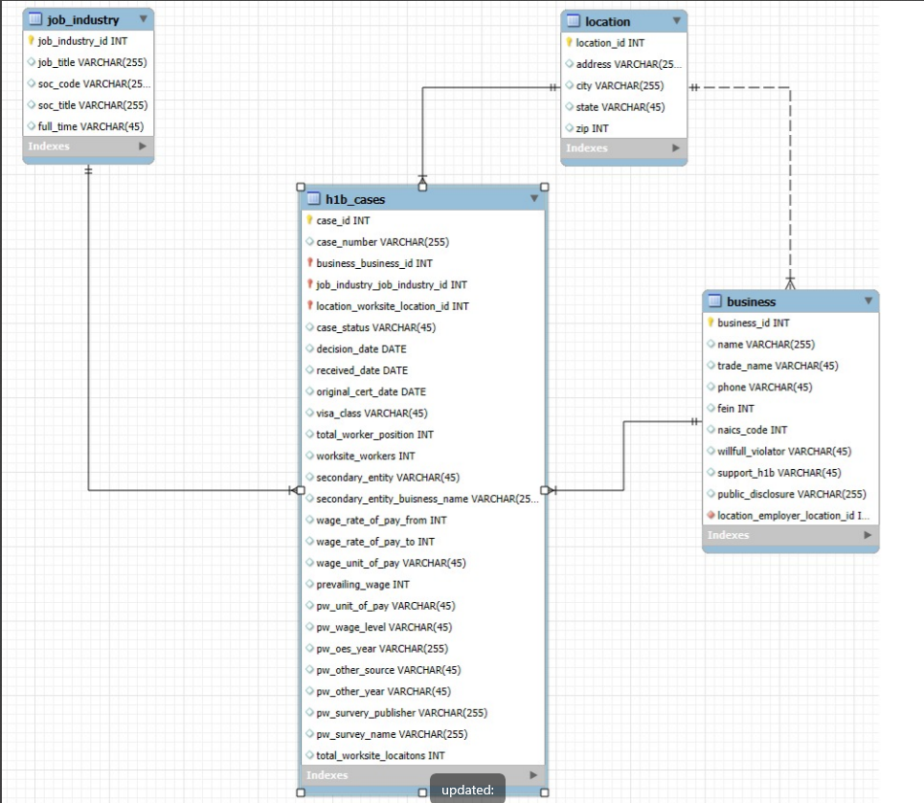

**Appendix 2 - PowerShell Commands**

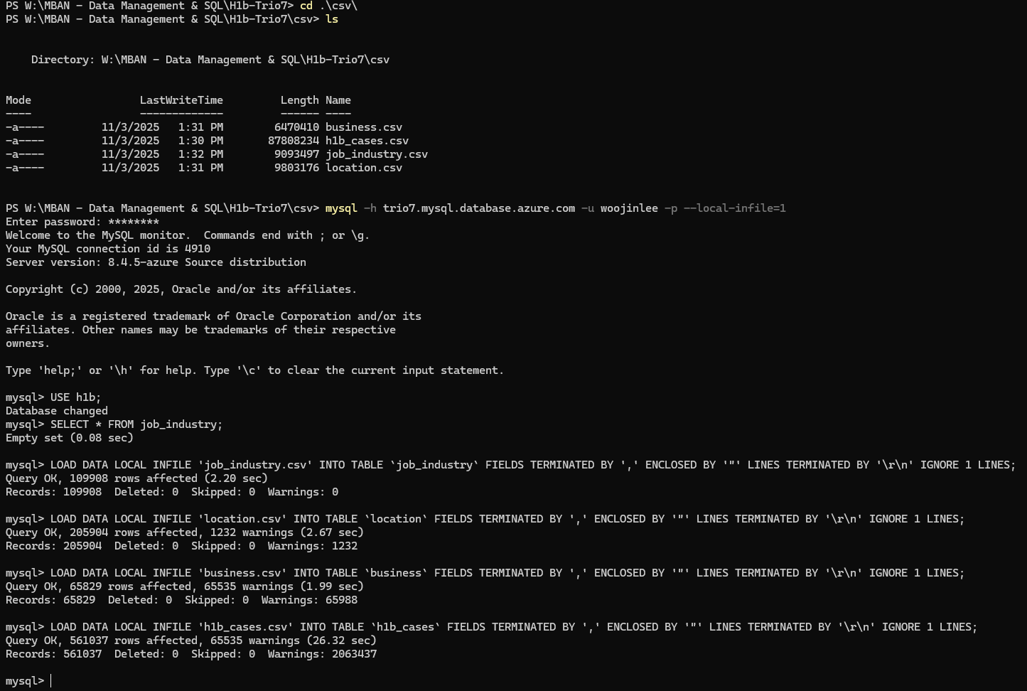

**Appendix 3 - Running SQL Commands on mySQL Workbench of the Uploaded Database**

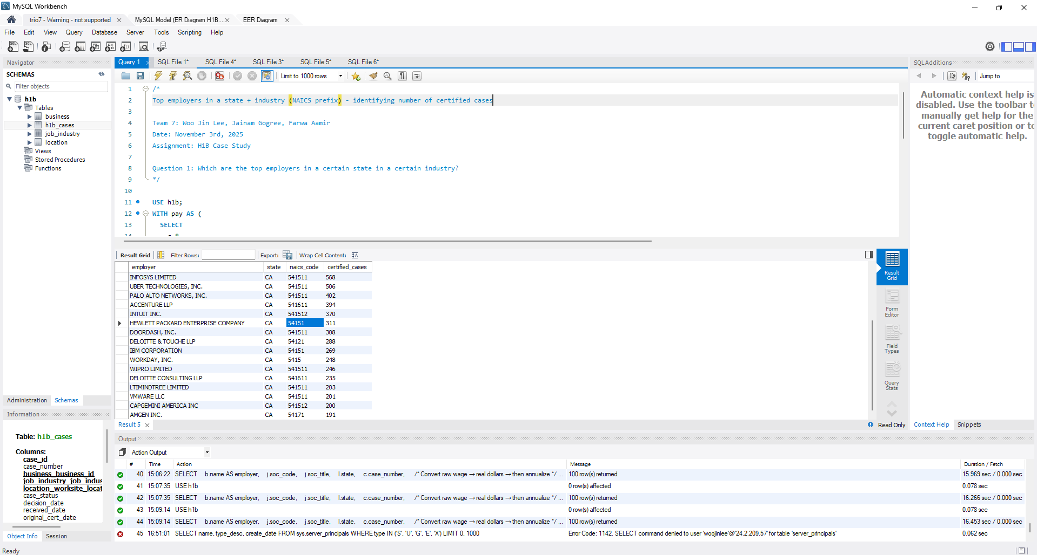

**Appendix 4a: SQL Queries On mySQL Workbench**

|  |
| --- |
| /* Top employers in a state + industry (NAICS prefix) - identifying number of certified cases  Team 7: Woo Jin Lee, Jainam Gogree, Farwa Aamir Date: November 3rd, 2025 Assignment: H1B Case Study  Question 1: Which are the top employers in a certain state in a certain industry? */  USE h1b; WITH pay AS (  SELECT  c.*,  COALESCE(YEAR(c.decision_date), YEAR(c.received_date)) AS fiscal_year,  CASE UPPER(REPLACE(c.wage_unit_of_pay,' ',''))  WHEN 'HOUR' THEN 2080 * c.wage_rate_of_pay_to  WHEN 'WEEK' THEN 52 * c.wage_rate_of_pay_to  WHEN 'BI-WEEKLY' THEN 26 * c.wage_rate_of_pay_to  WHEN 'MONTH' THEN 12 * c.wage_rate_of_pay_to  WHEN 'YEAR' THEN c.wage_rate_of_pay_to  ELSE NULL END AS annual_pay_high  FROM h1b_cases c ) SELECT b.name AS employer,  l.state,  b.naics_code,  COUNT(*) AS certified_cases FROM pay p JOIN business b ON b.business_id = p.business_business_id JOIN location l ON l.location_id = p.location_worksite_location_id WHERE p.case_status = 'Certified'  AND l.state = 'CA' -- ← change state  AND b.naics_code LIKE '54%' -- ← change NAICS prefix (e.g., '51%', '52%', etc.) GROUP BY b.name, l.state, b.naics_code ORDER BY certified_cases DESC LIMIT 25; |

**Appendix 4b: SQL Queries On mySQL Workbench**

|  |
| --- |
| **/* Which functions (SOC/job) pay the most (nationwide, certified only) - identifying the average max payout (cumulative of the cases)  Team 7: Woo Jin Lee, Jainam Gogree, Farwa Aamir Date: November 3rd, 2025 Assignment: H1B Case Study  Question 2: Which functions seem to pay the most? */  USE h1b;  WITH pay AS (  SELECT  c.*,  CASE UPPER(REPLACE(c.wage_unit_of_pay,' ',''))  WHEN 'HOUR' THEN 2080 * c.wage_rate_of_pay_to  WHEN 'WEEK' THEN 52 * c.wage_rate_of_pay_to  WHEN 'BI-WEEKLY' THEN 26 * c.wage_rate_of_pay_to  WHEN 'MONTH' THEN 12 * c.wage_rate_of_pay_to  WHEN 'YEAR' THEN c.wage_rate_of_pay_to  ELSE NULL END AS annual_pay_high  FROM h1b_cases c ) SELECT  j.soc_code,  j.soc_title,  j.job_title,  COUNT(*) AS n_cases,  ROUND(AVG(p.annual_pay_high),0) AS avg_max_pay FROM pay p JOIN job_industry j ON j.job_industry_id = p.job_industry_job_industry_id WHERE p.case_status = 'Certified'  AND p.annual_pay_high IS NOT NULL GROUP BY j.soc_code, j.soc_title, j.job_title HAVING COUNT(*) >= 30 -- raise/lower to control noise ORDER BY avg_max_pay DESC LIMIT 25;** |

**Appendix 4c: SQL Queries On mySQL Workbench**

|  |
| --- |
| **/* Outliers vs prevailing wage (ratio rule) - tech only  Team 7: Woo Jin Lee, Jainam Gogree, Farwa Aamir Date: November 3rd, 2025 Assignment: H1B Case Study  Question 3: Are there certain types of jobs concentrated in certain geographical areas?   / 100 and / 100 (because the gov stores money in cents not dollars and raw format updated data added 100) */  USE h1b;  SELECT  b.name AS employer,  j.soc_code,  j.soc_title,  l.state,  c.case_number,   /* Convert raw wage → real dollars → then annualize */  CASE c.wage_unit_of_pay  WHEN 'Hour' THEN (c.wage_rate_of_pay_to / 100 / 100) * 2080  WHEN 'Week' THEN (c.wage_rate_of_pay_to / 100 / 100) * 52  WHEN 'Bi-Weekly' THEN (c.wage_rate_of_pay_to / 100 / 100) * 26  WHEN 'Month' THEN (c.wage_rate_of_pay_to / 100 / 100) * 12  WHEN 'Year' THEN (c.wage_rate_of_pay_to / 100 / 100)  END AS annual_pay,   CASE c.pw_unit_of_pay  WHEN 'Hour' THEN (c.prevailing_wage / 100 / 100) * 2080  WHEN 'Week' THEN (c.prevailing_wage / 100 / 100) * 52  WHEN 'Bi-Weekly' THEN (c.prevailing_wage / 100 / 100) * 26  WHEN 'Month' THEN (c.prevailing_wage / 100 / 100) * 12  WHEN 'Year' THEN (c.prevailing_wage / 100 / 100)  END AS annual_prevailing  FROM h1b_cases c JOIN (  SELECT case_number, MAX(case_id) AS max_case_id  FROM h1b_cases  GROUP BY case_number ) x ON c.case_id = x.max_case_id JOIN business b ON b.business_id = c.business_business_id JOIN job_industry j ON j.job_industry_id = c.job_industry_job_industry_id JOIN location l ON l.location_id = c.location_worksite_location_id  WHERE c.case_status = 'Certified'  AND c.wage_rate_of_pay_to > 0  AND c.prevailing_wage > 0  ORDER BY annual_pay DESC LIMIT 100;** |

**Appendix 4d: SQL Queries On mySQL Workbench**

|  |
| --- |
| **/* Top Industry per State (by certified fillings)  Team 7: Woo Jin Lee, Jainam Gogree, Farwa Aamir Date: November 3rd, 2025 Assignment: H1B Case Study  Question 4: What set of advice would you give the current students to maximize their chances of being sponsored by the H1B visa based on top industries per state certified? */ USE h1b;  SELECT s.work_state, s.industry_name, s.filings FROM (  SELECT  loc.state AS work_state,  ji.soc_title AS industry_name,  COUNT(*) AS filings,  RANK() OVER (PARTITION BY loc.state ORDER BY COUNT(*) DESC) AS rnk  FROM h1b_cases c  JOIN job_industry ji ON ji.job_industry_id = c.job_industry_job_industry_id  JOIN location loc ON loc.location_id = c.location_worksite_location_id  WHERE c.case_status IN ('CERTIFIED','CERTIFIED-WITHDRAWN')  GROUP BY loc.state, ji.soc_title ) AS s WHERE s.rnk = 1 ORDER BY s.filings DESC;** |

**Appendix 4e: SQL Queries On mySQL Workbench**

|  |
| --- |
| **/* Most common H-1B worksites cities  Team 7: Woo Jin Lee, Jainam Gogree, Farwa Aamir Date: November 3rd, 2025 Assignment: H1B Case Study  Question 6:  */ USE h1b;  SELECT   wl.city AS worksite_city,  wl.state AS worksite_state,  COUNT(*) AS total_filings FROM h1b_cases c JOIN location wl   ON wl.location_id = c.location_worksite_location_id WHERE c.case_status = 'Certified' GROUP BY wl.city, wl.state ORDER BY total_filings DESC LIMIT 20;** |

1. Note: Please be aware that ChatGPT was used to clarify some concepts and to rephrase sentences used to improve clarity and readability; along with understanding and creating specific SQL queries to better understand the data outputted from the SQL server. None of the content on this report was generated by OpenAI or has been used to create this work.